# Project Planning Phase

**Project Planning Template (Product Backlog, Sprint Planning, Stories, Story points)**

|  |  |
| --- | --- |
| Date | 22-11-2023 |
| Team ID | Team-593176 |
| Project Name | Project - Market Segmentation Analysis Using ML |
| Maximum Marks |  |

Product Backlog, Sprint Schedule, and Estimation (4 Marks)

Use the below template to create product backlog and sprint schedule

|  |  |  |  |  |  |  |
| --- | --- | --- | --- | --- | --- | --- |
| **Sprint** | **Functional Requirement (Epic)** | **User Story Number** | **User Story / Task** |  | **Priority** | **Team Members** |
| Sprint-2 | Project setup &  Infrastructure | USN-1 | Set up the development environment with the required tools and  frameworks to start the market segmentation analysis |  | High | varsha |
| Sprint-2 | development environment | USN-2 | Gather lots of information about the market segment and about their loses and profits |  | High | varsha |
| Sprint-1 | Data collection | USN-3 | Preprocess the collected dataset by resizing images, normalizing pixel values, and splitting it into training and validation sets. |  | High | Harshitha |
| Sprint-1 | data preprocessing | USN-4 | Explore and evaluate different deep learning architectures (e.g., CNNs) to select the most suitable model for garbage classification. |  | High | Harshitha |
| Sprint-3 | model development | USN-5 | train the selected deep learning model using the preprocessed  dataset and monitor its performance on the validation set. |  | High | Spoorthy |
| Sprint-3 | Training | USN-6 | implement data augmentation techniques (e.g., rotation, flipping) to improve the model's robustness and accuracy. |  | medium | Spoorthy |
| Sprint-4 | model deployment & Integration | USN-7 | deploy the trained deep learning model as an API or web service to make it accessible for garbage classification. integrate the model's API into a user-friendly web interface for users to upload images and receive garbage classification results. |  | medium | Madhuhitha |
| Sprint-4 | Testing & quality assurance | USN-8 | conduct thorough testing of the model and web interface to identify and report any issues or bugs. fine-tune the model hyperparameters and optimize its performance based on user feedback and testing results. |  | medium | Madhuhitha |

Project Tracker, Velocity & Burndown Chart: (4 Marks)

|  |  |  |  |  |  |  |
| --- | --- | --- | --- | --- | --- | --- |
| **Sprint** | **Total Story Points** | **Duration** | **Sprint Start Date** | **Sprint End Date (Planned)** | **Story Points Completed (as on Planned End Date)** | **Sprint Release Date (Actual)** |
| Harshitha Mandula | 7 | 6 Days | 06-Nov 2023 | 19-Nov-2023 | 20 | 09-Nov- 2023 |
| Varsha kolla | 10 | 7 Days | 04-Nov 2023 | 18- Nov 2023 |  |  |
| Madhuhitha | 8 | 7 Days | 08- Nov 2023 | 17-Nov- 2023 |  |  |
| Spoorthy | 7 | 6 Days | 09- Nov 2023 | 20-Nov- 2023 |  |  |
|  |  |  |  |  |  |  |
|  |  |  |  |  |  |  |
|  |  |  |  |  |  |  |
|  |  |  |  |  |  |  |

Velocity:

Imagine we have a 29-days sprint duration, and the velocity of the team is 20 (points per sprint). Let’s calculate the team’s average velocity (AV) per iteration unit (story points per day)

AV=Sprint duration/velocity

# AV= 12/10=1.2

Burndown Chart:

A burndown chart is a graphical representation of work left to do versus time. It is often used in agile [software development](https://www.visual-paradigm.com/scrum/what-is-agile-software-development/) methodologies such as [Scrum](https://www.visual-paradigm.com/scrum/scrum-in-3-minutes/). However, burn down charts can be applied to any project containing measurable progress over time.

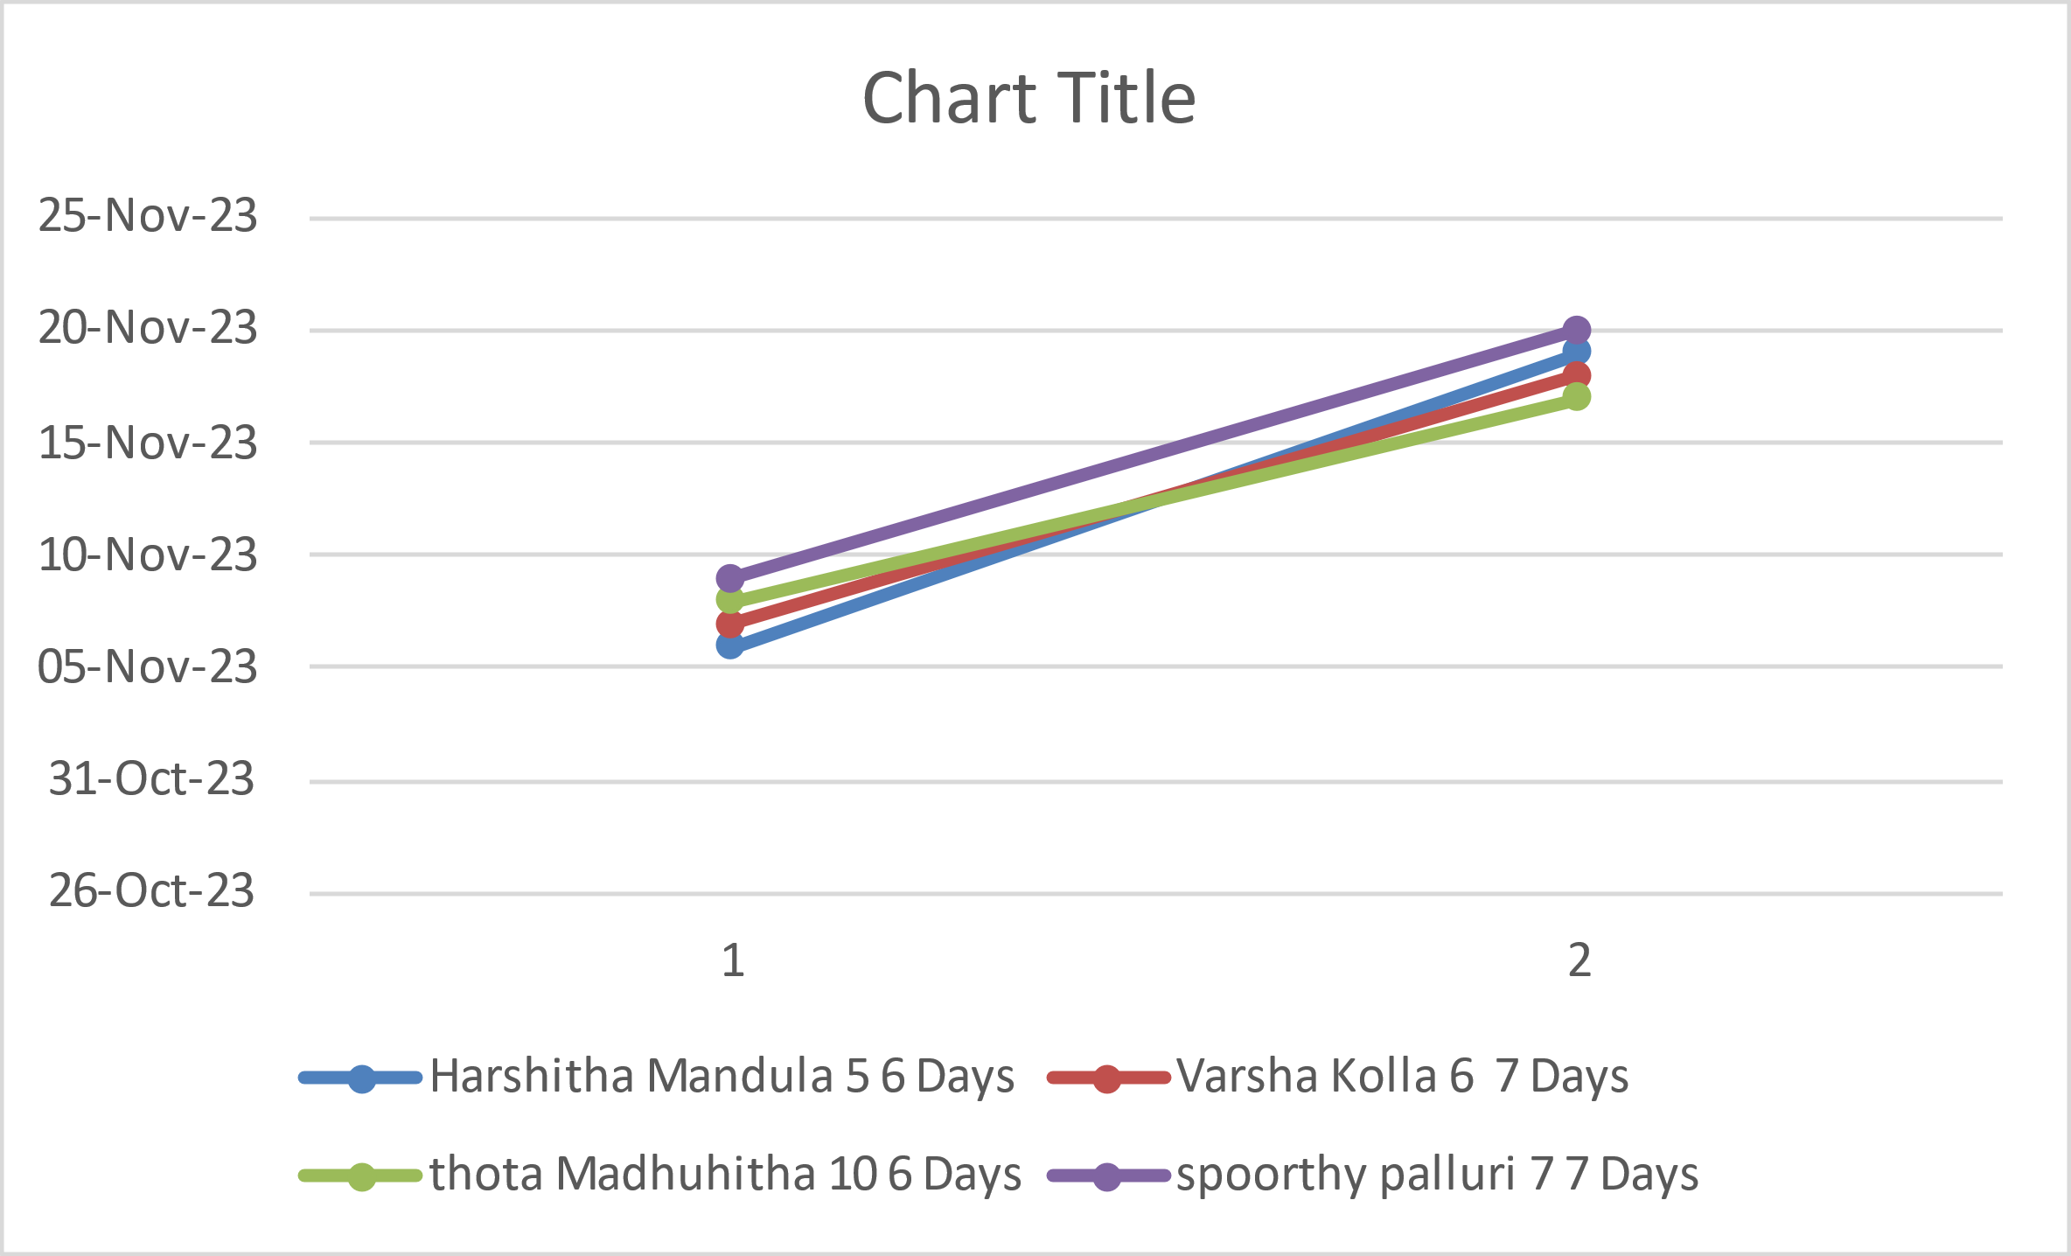

Reference:

<https://www.atlassian.com/agile/project-management> <https://www.atlassian.com/agile/tutorials/how-to-do-scrum-with-jira-software> <https://www.atlassian.com/agile/tutorials/epics> <https://www.atlassian.com/agile/tutorials/sprints> <https://www.atlassian.com/agile/project-management/estimation> <https://www.atlassian.com/agile/tutorials/burndown-charts>